Project Name
Content Usability Scorecard

Prepared by: [Name]
[Title]
[Name of Company]

March 16, 2016

Contents

Methodology Overview 3
Summary of Findings 3
Scenario 1 4
Summary of Recommendations 6

Methodology Overview
We evaluated the content on [project site] against [X] criteria in [X] categories. These criteria represent industry best-practices and standards for content usability.
We focused our evaluation on [X] web pages reflecting these user scenarios:
- List user scenarios
- List user scenarios
The coloured ratings in this scorecard make it easy to see the areas of strength and weakness.
Examples and recommendations are given for each rating category to help you understand how the ratings are determined and how to make improvements. Details of how we determined individual criteria ratings are available on request.

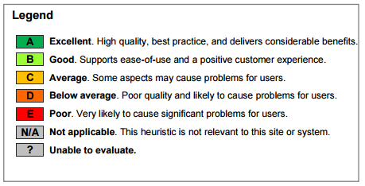

Summary of Findings
[This is where you relate the findings to the key business goals.]

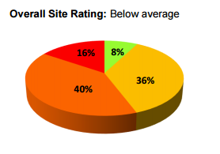

Key Recommendations
Focus content improvements on these three areas that offer the greatest opportunity for improved usability:
- Recommendation 1
- Recommendation 2
- Recommendation 3

Scenario 1
“I just bought a blue widget device but it doesn’t work with my laptop. I want to return it and get a red widget device.”

Are the information design and writing standards professional and effective?
 |  | A | B | C | D | E | N/A
1.1 | Content has no spelling or grammatical errors |  |  | C
1.2 | Content is easy to read and understand |  | B
1.3 | Titles, headings, and text are consistent and effective |  | B
1.4 | Content is supported graphically | A
1.5 | Content is easy to scan |  |  | C

For each user scenario, create a scorecard for each category. The scorecard lists the criteria to assess. Work through the scenario, following the pages and flows presented on the website. Score your experience for each of the criteria by entering the grade in the appropriate cell. Apply colour to the cell to make the scorecard easy to read.
Tip: When selecting criteria to assess, focus on the areas that are most important to you. Don’t try to evaluate everything.

[Screenshot demonstrating key discussion points]

Example
Text-heavy pages are difficult to scan (1.5)
Usability improves when users can grasp meaning at a glance

Recommendations
- List recommendations
- List recommendations
- List recommendations

Summary of Recommendations
[Provide a list of content recommendations and next steps. Assign priorities and sequences to the recommendations if appropriate.]

